Living with Dementia

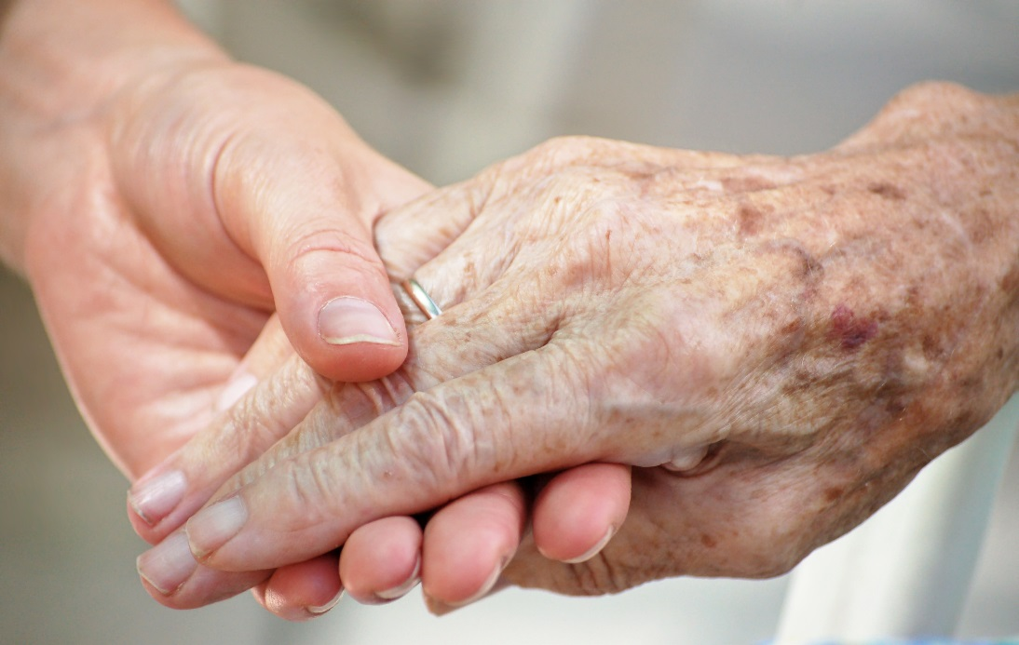

Introduction
A Ghrá Care Services recognises that Dementia is unique and that it affects everyone differently. Our aim is to support families and to help them look after their loved ones at home for as long as possible. Our support includes providing a high-quality care service together with advice and information. With this in mind we designed our information pack to provide an overview of dementia and its effects on the individuals and their families. We feel that an understanding of dementia will help to equip families, friends and care staff with the extra knowledge and skills required to engage effectively with people living with dementia.

When A Ghrá Care Services receives an enquiry to provide dementia care our dementia care advisory team arrange a visit with the family and the person with dementia to assess the need and match the person and the care giver. The team will then develop a specific care plan for each person taking into account the person’s ability. The care plan is reviewed regularly in partnership with family members and health care professionals. Our experienced staff are specifically trained in dementia care to deliver high quality person centred consistent care while encouraging the person’s independence and dignity at all times.

What is Dementia
Dementia is an umbrella term used for a range of symptoms caused by impairment to the brain. Dementia is a progressive and irreversible decline of mental abilities. Dementia affects personality, memory, language, behaviour and ability to perform normal everyday activities.

Statistics
There are 50,000 people with dementia in Ireland at present and over 500,000 people living in families who are affected. The highest rates per head of population are in the West of Ireland. There are over 5,000 people living with dementia in Galway, Mayo and Roscommon. These figures are expected to treble in the next 25 years.

Age Profile
Dementia usually affects people over 65. Dementia is not a normal part of ageing. People in their 40s and 50s are now getting dementia.

Types of Dementia
The most common types of dementia are Alzheimer's, Vascular, Lewy Body and Frontotemporal dementia. All types of dementia share many similarities. Some other conditions can produce symptoms similar to dementia. Most cases of dementia are not inherited.

Diagnosis
Early diagnosis is essential. The first step is to talk to the GP who will usually refer to a specialist. While there is no one diagnostic test there are a number of tests and assessments undertaken to rule out other causes of symptoms

Financial/Legal Planning Ahead
It is important that families talk to the person with dementia at an early stage about the diagnosis and life with dementia. Planning for the future is essential so that family members are aware of their loved ones’ wishes. Legal and medical advice on an Enduring Power of Attorney must be sought while the person with dementia is able to manage legal and financial affairs.

Treatment for Dementia
At present, there is no prevention or cure for most forms of dementia. Some medications may reduce symptoms. Support is vital for people living with dementia. Understanding dementia is a prerequisite to providing sensitive person centred care.

Reduce Risk of Developing Symptoms of Dementias
- Healthy Diet
- Exercise
- Supplements – vitamin B Complex, Fish Oils, vitamin D and magnesium (check with GP for possible medication interactions).
- Mental Stimulation – crosswords, puzzles, scrabble or Sudoku; learn something new.
- Manage stress

Vascular Dementia
Vascular dementia is caused by brain impairment from restricted blood flow to the brain. Vascular dementia can develop after a stroke which blocks an artery in the brain. However, strokes are not always the cause. Multiple mini strokes can occur causing symptoms to worsen in a step wise progression.
Vascular dementia affects reasoning, planning, judgement, memory and ability to perform every day activities. Symptoms can include depression and mood swings.
Risk factors include high blood pressure, high cholesterol, diabetes, heart disease and history of strokes.
Some people have both Alzheimer's disease and vascular dementia.
Medications available to treat Alzheimer’s disease can also be effective for vascular dementia. These drugs can improve memory, thinking and behaviour for a time but they do not cure the disease or prevent eventual deterioration.

Lewy Body Dementia
Symptoms of Lewy Body dementia include difficulty with concentration and attention, confusion, visual hallucinations, tremors and stiffness. A change in walking pattern or stiffness can result in falls. Lewy Body dementia can overlap with Parkinson’s disease – Parkinson’s Dementia.

The person may:
- be lucid and clear at one time and confused and disoriented at other times.
- experience delusions and/or depression
- cope better having one to one time.

Frontotemporal Dementia
Frontotemporal dementia (previously referred to as Pick’s disease) is caused by progressive damage to the frontal and temporal lobes of the brain.

Frontotemporal dementia affects language, judgement and behaviour. The person’s memory often remains unaffected.

Symptoms usually begin between ages of 40 to 65 and can include, fixed mood and behaviour; unable to adapt to new situations, loss of empathy, emotional warmth, lack of motivation and avoiding social contact. There may be a decline in self-care and personal hygiene and the person may also experience changes in eating patterns, craving sweet foods, overeating or unusual food preferences. The person may become obsessive, or repeat patterns of movement or behaviours.

Alzheimer’s Disease
Alzheimer’s disease is the most common form of dementia. Alzheimers is progressive and irreversible. At present, there is no known cause and no cure. The course of Alzheimers can range from 4 years to 20 years. The risk factors include, old age, family history of dementia, Down Syndrome and Parkinson’s disease. Definite diagnosis can only be had on autopsy.

Stages of Alzheimer’s Disease
Alzheimers usually starts slowly and progresses in stages. According to some experts there are seven stages. The first two stages occur before the person realises they have dementia or before dementia is evident to loved ones or health care professionals. The three main stages are Early (mild), Middle (moderate) and Late (severe). The effects of Alzheimers varies greatly from person to person. Not everyone will go through all stages – the person can go from forgetfulness to dependency in a few years.

Alzheimer’s Disease Stage 1
- Show signs of short term memory loss.
- Have little interest in reading, tv., etc.
- Have language difficulty – repeat own and others speech.
- Be slower to react – lack spontaneity and initiative.

Alzheimer’s Disease Stage 2
- Become hostile or agitated - show signs of anxiety and depression.
- Be distrustful of other people - have difficulty recognising family members.
- Have changed sleep patterns.

Alzheimer’s Disease Stage 3
- Develop a change in personality
- Become paranoid and worry about money, feel insecure.
- Have greater loss of memory of recent and distant events.
- Have greater language difficulties - much slower in speech and understanding.
- Be unable to complete tasks.

Alzheimer’s Disease Stage 4
- Show a marked change in behaviour
- Be lost to time and place - unable to recognise people.
- Experience sleep disturbance.
- Have walking difficulties/Wandering.
- Become incontinent.

Alzheimer’s Disease Stage 5 or Final Stage
- Experience severe deterioration - increased confusion
- Have problems with eating.
- Experience loss of voluntary movement.
- Be unable to communicate.
- Require full nursing care.

Living Alone with Dementia
It is estimated that one third of people with dementia who live at home live alone. Well supported people with dementia can live independently in their own home for quite some time. However, the situation should be reviewed regularly by family members and professionals. The top 6 issues for some vulnerable people living alone with dementia are:

- Often late or no formal diagnosis
- Financial and legal issues – money management, abuse and exploitation
- Medication management
- Self-neglect, malnutrition and poor health outcomes
- Loneliness and social exclusion
- Safety concerns- falls, fires, wandering

- Late or No formal diagnosis
People living alone with dementia are less likely to have a formal diagnosis or receive a timely diagnosis than people living with others. Home care providers are often the first to notice signs and symptoms of dementia. Collaboration with GP’s and other health care professionals will be necessary to start the process of diagnosis. Individuals have the right to refuse to visit GP and may not want to know that they have dementia. An early diagnosis is essential to access dementia specific services. Families and service providers can explain to the person that they have a better chance of staying in their own home for longer if they accept help from services and local supports.

- Financial and Legal Issues
When a person is diagnosed with dementia it does not necessarily mean that the person no longer has capacity. However, completion of financial and legal matters should be encouraged. Planning ahead enables the person to have choice and control over their care and living arrangements while they have the capacity. Planning ahead can also reduce the risk of the person being taken advantage of or abused. When the person’s capacity is in question a formal assessment by a specialist is required. People living alone with dementia who have not planned ahead, have no family support or have family in conflict will often require an application to be appointed a Ward of Court.

- Medication Management
People living alone with dementia are at increased risk of medication mismanagement. Liaising with GP, Public Health Nurse and other health care professionals is essential to manage the person’s medication. Pharmacies can advise on suitable medication packs.

- Self-neglect, malnutrition and poor health outcomes.
People living alone with dementia are at risk of malnutrition and self-neglect. They need care that is delivered in a flexible and consistent manner by regular and familiar care staff. Care staff should have dementia specific training and have the skills required to be able to build a relationship with their client.

Ways to monitor meals and malnutrition include:
- Check fridge, freezer, and food cupboards weekly to see what has been eaten.
- Check if a ‘Meals on Wheels’ service is required.
- Ensure that care staff are scheduled at meal times to assist the person.
  - Ensure that healthy snacks and meals are readily accessible.
Ways to assist with self-care and hygiene include:
- Check if the person would like a bath or shower - make bathing a pleasurable activity.
- Ensure wounds are treated and managed by Public Health Nurse service.
- Provide assistance with continence management.

- Loneliness
People living alone with dementia may experience loneliness and feel socially isolated. As well as providing day to day personal care needs, services should support and facilitate opportunities for social engagement.

Ways to alleviate feelings of loneliness include:
- Regular visits from family, friends and neighbours.
- One to one support provided by local contact volunteer services.
- Outings and car trips.
- Day Care Centres that are designed for people with dementia are an ideal service option.

- Safety Concerns
Wandering, falls and fires are a concern for people living alone with dementia.
Ways to deal with these concerns include:
- Make changes and declutter to keep the environment safe.
- Advise friends and neighbours about the wandering ask them to let you know if they see the person out walking unaccompanied.
- Establish a routine and keep the person busy by involving them in meaningful and appropriate tasks about the house.
- Ensure there is someone with the person at times of restlessness,
- A physiotherapist can conduct a falls and mobility assessment.
- An occupational therapist can conduct home safety assessments to assess for adaptive equipment, environmental changes and give advice on assistive technologies. Devices that respond to the user rather than those that are user activated are more likely to be helpful and appropriate for people living alone with dementia. Assistive technologies include: GPS tracking devices; fall detectors; emergency call pendants; smoke alarms; gas detectors and sensor lights.

Dementia - Effects on Families and Care Staff
Caring for a person with dementia can put physical and emotional demands on families and care staff. Families can experience a range of different feelings and emotions – grief, bereavement, anger and resentment because their loved one has been diagnosed with this painful and challenging illness. It is important that the families and carers look after themselves and accept that they will need support and assistance to care for the person with dementia.

Families can feel guilty if the time comes when they can no longer care for the person at home and residential care is the best option. At this time families need to know that they can still be involved in their loved one’s care by visiting, arranging outings for the person and having an input into the care plan. It is vital to manage stress and ensure that support is there so that they can continue their caring role for as long as is necessary.

Issues affecting families may include:
- Safety concerns – falls, fires, wandering
- Lack of or poor communication.
- Family Dynamics – non-acceptance
- Embarrassment – out of character behaviour of the person with dementia.
- Loneliness – friends and neighbours not visiting
- Worry about the care and wellbeing of the person with dementia.
- Unwillingness of the person with dementia to accept medical or social help
- Lack of awareness
- Guilt/Sadness/Anger

Issues affecting Care Staff may include:
- Longer time needed to deliver care to the person with dementia and time being limited.
- Lack of, or poor communication
- Medication management
- Unwillingness of the person with dementia to accept help
- Safety concerns when leaving the person alone after a visit

Tips to help families to look after themselves:
- Learn about dementia. Information can play an important part in helping to understand how dementia can affect the person’s ability to communicate, behave and manage relationships.
- Seek help and support from friends and neighbours.
- Hold regular family meetings to share concerns, explore options and make suggestions about the person’s care plan.
- Make short term plans for the future to take into account the changing needs of the person.
- Create a schedule
- Remember that the person with dementia is not being difficult on purpose – their emotions and behaviours are affected by dementia.
- Try and maintain your interests, social contacts and lifestyle.
- If possible avail of supports that give respite – regular breaks are better for everybody.
- Be aware of concerns and challenges facing care staff.
- Family dynamics – non-acceptance of some family members

Effective Engagement with the person with dementia

Effective Engagement – Do’s
- Talk to the person so that you understand his/her history, likes and dislikes.
- Observe – if the person cannot communicate you can learn a lot from careful observation.
- Liaise with other family members.
- Focus on the person’s ability.
- Be aware of the person’s physical, intellectual, psychological, emotional, social and spiritual needs.
- Remember the person’s right not to participate.
- Use visual prompts and cues.
- Sit beside the person and make eye contact.
- Identify yourself by name. Address the person by name.
- Be aware of tone of voice - speak directly to the person slowly and in pleasant respectful manner
- Be patient – if the person is struggling to find a word suggest word.
- Use nonverbal communication if necessary – demonstrate i.e. how to brush teeth.
- If appropriate use touch.

Effective Engagement – Don’ts
- Don’t focus on logic – focus on feelings
- Don’t take it personally
- Don’t argue or confront – distract
- Do not force routines that are inconsistent with the person’s history or needs.
- Do not talk to the person like you would talk to a child.
- Do not use long and complicated sentences.
- Do not use your phone while you are engaging with the person.

Activities
Activities are a very important part of the life of a person with dementia. Activities help to promote self-esteem, improve relationships and social contact and reduce boredom. Simple but meaningful activities can help to reduce anxiety, agitation and behaviour that challenges.

When planning activities take into account the person’s background, likes and dislikes and focus on maintaining residual skills and not new learning. Simple household chores chosen according to the person’s ability such as washing up, folding laundry, setting the table, etc., can help the person with dementia to feel useful.

Ask the person if she/he is happy carrying out the activity. Break down the activity into manageable steps. Limit confusion and noise – radio, tv., etc. Choose time of day best suited to the person. Activities should always be planned taking into account the safety and wellbeing of the person. Record the activities that the person enjoyed most.

Activities may include:
- Music Therapy
- Reminiscence
- Gentle exercise
- Art
- Mental stimulation – jigsaws, crosswords, Sudoku.
- Outings
- Sensory experiences – hand massage, smelling fresh flowers in the garden
- Hair styling/brushing.
- Visit to a pet farm
- Pet Therapy
- Photo Albums
- Rummage Box
- Watching a favourite tv programme
- Household chores (as above)

Managing Behaviours that Challenge
Changed behaviour can be challenging – remember this behaviour is not deliberate. The person may often direct anger and aggression at close family members.

Identifying triggers can eliminate behaviours that challenge. A calm unstressed environment and familiar routine can help to manage difficult behaviour. Be consistent in your approach. Reacting in a calm and patient way can influence behaviour. A simple smile can reassure and comfort.

Observe and record behaviour. Talk with the doctor about behaviour changes. Adapting the care plan to meet the needs of your loved one can help to reduce situations where challenging behaviour may occur.

Using the ABC model can help you to understand and identify triggers of behaviour that challenges. Identifying the triggers can help you to find ways to reduce the behaviour -
“A” Antecedents; “B” Behaviour; “C” Consequences

“A” Antecedents - What events lead up to the behaviour?
- Is the person hungry?
- Is the person unhappy with an activity?
- Where does it happen? Is the environment noisy or cluttered?
- When does it happen? i.e. same time or same day?
- Is there an underlying illness?

“B” Behaviour - What behaviour challenges? Does the person:
- push you away when you are providing care?
- repeat questions?
- become aggressive or shout at you?
- pace around or wander?

“C” Consequences - What happens as a result of the behaviour?
- Are triggers identified?
- How is the problem dealt with?
- Are necessary changes made?
- How do you react? Do you respond in a calm reassuring way?

Responses to Common Behaviours that Challenge
- Aggression - physical/verbal - remain calm, distract appropriately, check the person’s needs, give the person space.

- Hoarding/Hiding Behaviour - provide a drawer or box full of odds and ends to keep the person busy. Be aware of the person’s usual hiding places to check for missing items.

- Repetitive/Clinging Behaviour - Distract appropriately, go for walk with the person, make tea or involve the person in some other activity.

Dementia Friendly Environment
A dementia friendly environment will help to support the person with dementia to maintain independence and wellbeing. A dementia friendly environment allows easy access and orientation within the person’s home providing support for doing things the person enjoys and helping the person to participant in daily activities.

Ways to create and maintain a dementia friendly environment may include:
- Adjusting surroundings to meet the person’s capabilities.
- Keep rooms simple and familiar.
- Balance lighting.
- Ensure that there is no glare from windows.
- Remove floor clutter, coffee tables, mats, etc. to reduce risk of falls.
- Place a clock and calendar in the room.
- Place family photographs on display.
- Leave the bathroom door open to remind the person to enter.
- Make sure water is not too hot or too cold.
- Large signs, pictures, arrows and colours can help the person find his/her way around.
- Ensure the pathways and garden areas are safe and clear.
- Ensure there are shaded places for the person to sit and relax and enjoy the garden.
- Ensure that plants, water features, etc., are safe and clearly defined.

Some Important Points to Remember
- The person is present – don’t talk about the person in his/her presence as if she/he is not there.

- Dignity, Respect and Vigilance.

- Continue to enjoy your loved ones’ company – they will enjoy yours.

- Put yourself in your loved ones’ shoes.

Support Services Available
- A Ghrá Care Services
- HSE
- Western Alzheimers
- Alzheimers Society of Ireland
- Dementia Elevator online programme

A Ghrá Care Services
- Supports independence in the home
- Delivers high standard, safe, secure and flexible care planned to meet needs
- Fully trained and qualified experienced carers
- Recognises and respects privacy and dignity for all
- HSE approved and EIQA member
- Value for money supplemented by possible tax relief.

References/Resources
- Alzheimers Australia, About Dementia Help Sheets.
- Dementia Elevator online.
- Dementia Services and Development Centre, St. James Hospital.

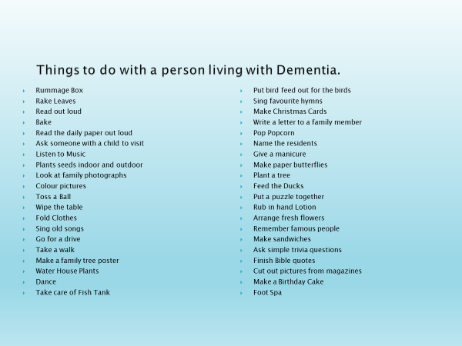

This information pack is intended to give general information only to families and care givers of people with dementia. People should seek advice from their doctor on their particular case. A Ghrá Care Services is not responsible for any error or omission in the information pack.


